NAIDOC WEEK 2020: Always Was, Always Will Be
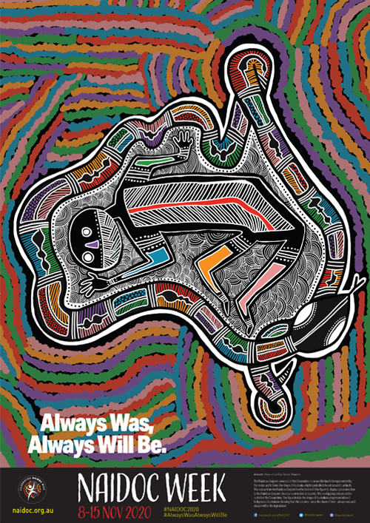
The 2020 National NAIDOC Poster: ‘Shape of Land’ by Tyrown Waigana
What is NAIDOC Week?
NAIDOC Week celebrates the history, culture and achievements of Aboriginal and Torres Strait Islander peoples and is celebrated by Indigenous and non-Indigenous communities alike.

NAIDOC originally stood for the National Aborigines and Islanders Day Observance Committee, which arranged events for the week. Its acronym has since become the name of the week itself. To find out more about the history of NAIDOC, visit this page on the NAIDOC website.

NAIDOC celebrations are usually held at the start of July, however due to the pandemic this year, the National NAIDOC Committee (the Committee) postponed celebrations to 8 – 15 November. Each year, a theme is chosen to reflect the important issues and events for NAIDOC Week.

What does this year’s theme mean?
For this year’s NAIDOC celebrations, the Committee chose the theme ‘Always Was, Always Will Be’. The theme recognises that First Nations people have occupied and cared for this continent for 65,000+ years. Aboriginal and Torres Strait Islander people were Australia’s first explorers, navigators, engineers, farmers, botanists, scientists, diplomats, astronomers and artists. ‘Always Was, Always Will Be’ acknowledges that the very first footprints on this continent were those belonging to First Nations peoples and invites all Australians to embrace the oldest continuing cultures on the planet.

What does this year’s poster symbolise?
The poster this year, called ‘Shape of Land’ by Noongar and Saibai Islander man Tyrown Waigana, tells the story of the Rainbow Serpent. The Serpent, represented by the snake, came out of the Dreamtime to create this land. The shared colours of the Rainbow Serpent and figure symbolising First Nations peoples show the deep connection with Country, and that this land ‘Always Was, Always Will Be’ Indigenous land.
To download your own copy of the poster, visit this page on the NAIDOC website.

How can I get involved?
NAIDOC Week celebrations are held around the country to celebrate the many achievements of Aboriginal and Torres Strait Islander peoples. The Department of Education and Training (DET)’s Wirnalung Ganai Champions will run local events in their business areas centred around the NAIDOC Week theme. Business areas are also encouraged to host their own events to celebrate NAIDOC Week and continue their learning journey and efforts towards reconciliation.

There are a number of exciting whole-of-government and community events listed on the next page. Get along if you can.

Ways to support Aboriginal and Torres Strait Islander colleagues
- Build your cultural understanding and find practical ideas on Aboriginal inclusion every day here.
- Conduct an Acknowledgement of Traditional Owners at events and meetings, learn how here.
- Learn more about the DET’s Aboriginal Inclusion Plan, Wirnalung Ganai here.
- To book into Aboriginal Cultural Awareness training email diversity@education.vic.gov.au

Whole of Government NAIDOC Week Virtual Events
Victorian Departments have collaborated to offer the following events that all VPS staff are welcome to attend.

- NAIDOC Event
This event marks NAIDOC Week in Victoria. There will be a special address from Minister Williams, Minister for Aboriginal Affairs, a guest performance by the Djirri Djirri dancers as well as a musical performance.
When: Tuesday 10 November 12pm – 1pm
Attendance: Log into the event just before start time at this link
All VPS staff welcome.

- NAIDOC Week Panel Discussion
A panel discussion which will be facilitated by the multi-talented actor, director and organiser for the Media Entertainment Arts Alliance, Elaine Crombie. Elaine is a proud Pitjanjtajtarra, Warrigmal, South Sea Islander woman with German ancestry, and will bring her humour and intellect to an engaging discussion about this year’s NAIDOC Week theme and the Victorian Treaty process. Panel members contributing to the discussion include:
- Aunty Geraldine Atkinson, Co-Chair of the First People’s Assembly of Victoria
- Terry Garwood, Deputy Secretary, Local Infrastructure, Department of Environment, Land, Water and Planning
- Nicole McCartney, Chief Aboriginal Health Advisor, DHHS
- Bree Lovett, Project Officer, Department of Justice and Community Safety
Questions can be submitted to the panel by 6 November to mikala.purton@dhhs.vic.gov.au
When: Wednesday 11 November 12pm – 1:30pm
Attendance: Log into the event just before start time at this link
All VPS staff are welcome to attend

- NAIDOC Week Panel Discussion Hosted by DPC: ‘Truth and Treaty’
The Department of Premier and Cabinet (DPC) will host a panel discussion which will be facilitated by Elly Patira, Executive Director, Social Policy Group. The panel is part of the ‘Deadly Event Series’ hosted by the Treaty Branch of DPC, which aims to provide a deeper understanding of the issues facing Aboriginal communities and why the Victorian Government is on the path to Treaty with Aboriginal Victorians. The panel discussion will help you develop a stronger understanding of the truth and justice process and how it relates to Treat.
When: Thursday 12 November 10am – 11:45am
Attendance: Please email DPC to request a calendar invitation at statetreatybranch@dpc.vic.gov.au
All VPS staff are welcome to attend

- Cooking Demonstration with Nornie Bero from Mabu Mabu
Join Nornie Bero, the wonderfully entertaining and passionate Torres Strait Islander chef, for an online showcase of Indigenous ingredients and a damper cooking session using traditional bush ingredients. Nornie will introduce us to a variety of native succulents, spices and herbs and teach us how to grow our own to bring Indigenous flavours to our meals. She will also share her personal story and how she came to open Mabu Mabu.
When: Friday 13 November 1pm – 2pm
Attendance: Log into the event just before start time at this link
All VPS staff are welcome to attend

Community Events in Your Area
To find other community events happening in your area, visit the official NAIDOC Week website and simply filter the search to your locality.

For more information go to Koorie collaboration page or email diversity@education.vic.gov.au.

